# Chapter ONE

**1.1** Project background

Employees are the main force behind the success or failure of any company therefore their management is very important. Online leave Management System makes it easy for the employer to keep track of all records. This software allows the administrator to edit employees, add new employees as well as evaluate an employee’s performance. Employees can be managed efficiently without having to retype back their information in the database. You can check to see if there are duplicate positions employees in the database. A flexible and easy to use Employee Management software solution for small and medium sized companies provides modules for personnel information management thereby organization and companies are able to manage the crucial organization asset people.

The combination of these modules into one application assures the perfect platform for re-engineering and aligning Human Resource processes along with the organizational goals. This system brings about an easy way of maintaining the details of employees working in any organization. It is simple to understand and can be used by anyone who is not even familiar with simple employee’s system. It is user friendly and just asks the user to follow step by step operations by giving easy to follow options. It is fast and can perform many operations for a company

University of Eldoret is a larger organization with about 1000 employees this employees require proper management so as to ensure that they achieve their maximum productivity level, Uoe for instance, all its employees are required to manually apply for leave by filling up forms which is then be submitted to the human resource department for further processing, This all process is tiresome inefficient and also prone to loss of information which leads to unsatisfied employees hence affecting productivity. The system is an online platform where all this process are automated and be achieved more easily.

**1.2** Problem Statement

Manual leave applications and manual handling of employee information poses a number of challenges. An employee is required to fill in a form which may take several weeks or months to be approved. The use of paper work in handling some of these processes could lead to human error, papers may end up in the wrong hands and not forgetting the fact that this is time consuming and also costly. A number of current systems lack employee self-service meaning employees are not able to access and manage their personal information directly without having to go through their HR departments or their managers. Another challenge is that multi-national companies who have all the employee information stored at the headquarters of the company making it difficult to access the employee information from remote places when needed at short notice.

The above-mentioned problems can be solved by designing and developing an online leave system where employees are going to access all their information, apply for leave and do all other sort of activities online without necessarily visiting the human resource department.

**1.3** Objectives of the Study

* + 1. **General Objective.**

This study objective was to design and develop an online leave management system for efficient management of leave application over the internet by employees of a particular organization which will increase the overall efficiency in the process.

**1.3.2** **Specific Objectives is to;**

1. Analyze the current system used for applying leave in order to develop and establish a better system to improve the operations in leave management
2. Design a dynamic solution based on the information analysis acquired from data collection to develop a functional online leave management system.
3. Develop an online leave management system that meets the user requirements
4. Test the system if it meets the user requirements

**1.4** Project justification

Online leave management system is a significant system in streamlining all the aspects of human resource in any organization. It’s clear based on the current system that manual leave application is totally a primitive way of carrying out things in any organization. Thus, this online leave application system has revolutionized the human resource management in the following aspects:

**For the organization**

This system will improve discipline. Leave, when paired with attendance, can improve accuracy and build discipline in any organization. For instance, some companies may have a policy of enforcing a leave without pay if an employee misses work without the manager’s permission.

**For the employees**

This system is able to convey policy rules. It uses in-built systems to convey leave policy rules like maximum or minimum number of days, holiday calendar management according to location etc. Employees can, at any time, refer to the leave policy before applying for vacation days. This study has provided compliance to leave policy. Often, lack of knowledge about organizational leave policies, lead to negligence of leave policy rules by employees and managers. A Leave Management System uses inherent rules that do not allow employees or managers to bypass rules while applying for or approving leaves.

**For the HR manager**

This system is able to give accurate information. It provides accurate information about leave balances; leave trends etc. which allows you to forecast available resources at any point of time. This system provides instant information about employee’s leave history. It allows manager and HR to look at leave history of the applicant. Leave history for the department or company can also be extracted immediately.

This system is able to allow users to save time. Online leave balance visibility is able remove a tremendous strain on HR where as much as 15% of their time is spent in handling queries on leave balance for employees.

**1.5** Project scope

Online leave management system aims HR Department in general and the employees’ leave records section in particular. The employee’s leave section is solely responsible for keeping the leave and related records of employees and keeping track of their information. An employee is able to apply for leave, view his leave status, cancel leave application and view the number of leave days remaining. Also, the administrator is able to manage the accounts of both the HR and the employees i.e. adding and removing employee accounts, adding leave types adding and removing HR mangers who are responsible for approval and disapproval of leave applications

**1.6** Limitation

Usually, every work has some limitations and this study is not exempted. The two major limitations of this study are the time limits within which the study is expected to be completed as well as financial constraints. The time constraint prevents the researcher to have an in-depth study and analysis on the subject matter. While the issue of financial constraint limits, the frequency of investigation to/from the institution toward gathering the necessary information relevant for the study.

**1.6 Target Users**

Online leave management system is an all-integrated system that would serve its users efficiently. The administrator is one of the entities to use the system. He/she is allowed with privileges of logging in, adding and removing staff and leave types and their information, HR manager who are responsible for approving and declining of leave application and generation of monthly reports. The staff are able also use the system to apply for leave and other information that concerns them.

## **CHAPTER TWO**

### **LITERATURE REVIEW**

### **2.1** Introduction

Literature review is the evaluation of information found in existing literature related to selected area of study. It is an assessment of the existing literature and systems. Over the years different online systems have been developed for different organizations. However, little focus has been directed to such systems that have been developed to meet the requirements of employees of that particular organization. With a view to developing a better system, review of the existing literature and systems must be done so as to source information on their functionality. This involves identifying the functionalities of various modules of the existing system so as to gain basic idea of developing a system dynamic enough to compete strongly in the market. Information fetched is of great significance.

### **2.2** Theoretical Review

Theoretical review provides a benchmark into the existing system information. It is for gaining necessary information relevant to the area of study. Leave refers is a period of time that one must be away from one's primary job, while maintaining the status of employee. This contrasts with normal periods away from the workplace, such as vacations holidays hiatuses, sabbaticals and "working from home" programs, in that they are considered exceptional circumstances, rather than benefits. Generally such an arrangement has a predefined termination at a particular date or after a certain event has occurred (David & Abraham, 2010).There are several leave types that one can apply for in any kind of formal organization this include: sick leave, casual leave, maternity leave, paternity leave etc.(Whitehouse, Baird, & Hosking, 2012) The procedure of leave application in most of this organizations is that a staff member wishing to take leave will fill up the standard leave application form and apply to his head of department, the head of department will then forward his application to the human resource department for verification and further processing, the HR department will then process his application and approve or deny it depending on the available information provided by the employee applying for leave.

In an organization with large number of employees this process is more tedious since there will be a lot of logistics required to consider so as to process leave applications from the employees. Also, various problems like data loss and lots of paper work will arise from this kind of scenario, this problem can be solved by automating the whole process through the development of an online leave management system that carries out specific functions that are currently done manually, A recent study by the Hackett Group, a business process advisory firm found that high-performing organizations spend 25 percent less than their peers on HR because they use technology effectively. Majority of the organizations are shifting the focus to automating as many transactions as possible to achieve effectiveness and efficiencies in their human resources this new system has enable HR professionals to focus on transforming information into knowledge that can be used by the organization for decision making (Normalini & Sherah Kurnia, 2012).

## **2.3** System Review

This research is important to compare requirements and advantage of the system with what exists around that is why researcher has chosen to review a few examples of the systems which are related to the leave management services. The literature focuses on leave management systems in other parts of the world with no specific focus on University of Eldoret. Some of these systems include:

1. Eco-leave management system (http://www.e-leave.my/)
2. White beans-leave system(http://www.eleave.asia/)

Each of the sites offers very similar services to the users. The sites each have a different way of navigating and searching the site.

1. ECO-LEAVE MANAGEMENT SYSTEM

Eco-leave is a web-based leave management system that provides employees and management a platform to effectively manage leaves applications and approvals.  It aims at saving money and time and at the same time, saving the environment too by reducing paperwork. And because it is done online, employees and their supervisors can now apply or approve leaves whenever they want and wherever they are.

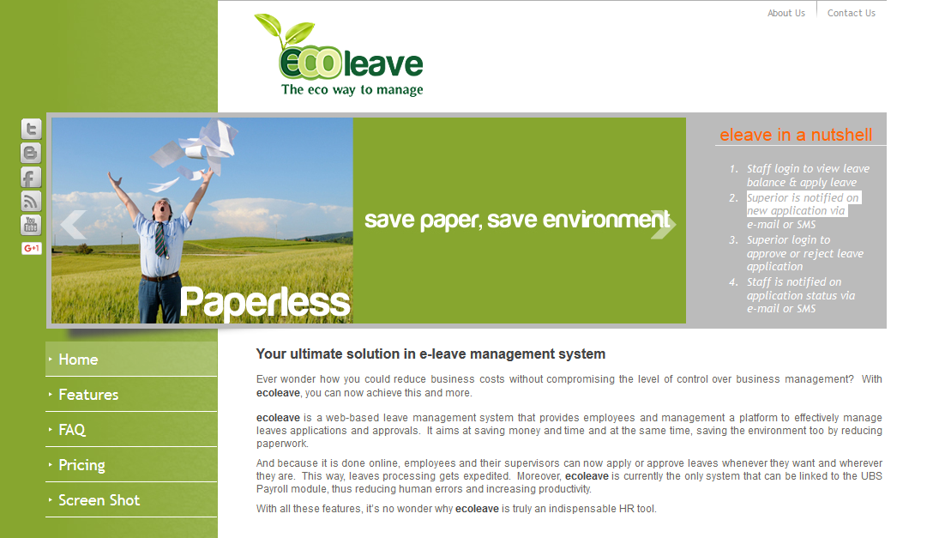

Figure 1 Eco leave management system

**2.**WHITE BEAN LEAVE MANAGEMENT SYSTEM.

White bean Leave is a web based system that allows employees to manage their leaves anywhere, anytime with internet access.Approvers will receive notification via email and approve/reject depending on the situation. Employees will also be notified via email once their leave is approved/rejected. Summary of their leave balance will also be displayed in the online Leave management system.This eliminates the hassle of going to the HR department to fill up a manual form, running around the company to get approvals from superiors and finally submitting the approved leave to HR department again for filing purposes.

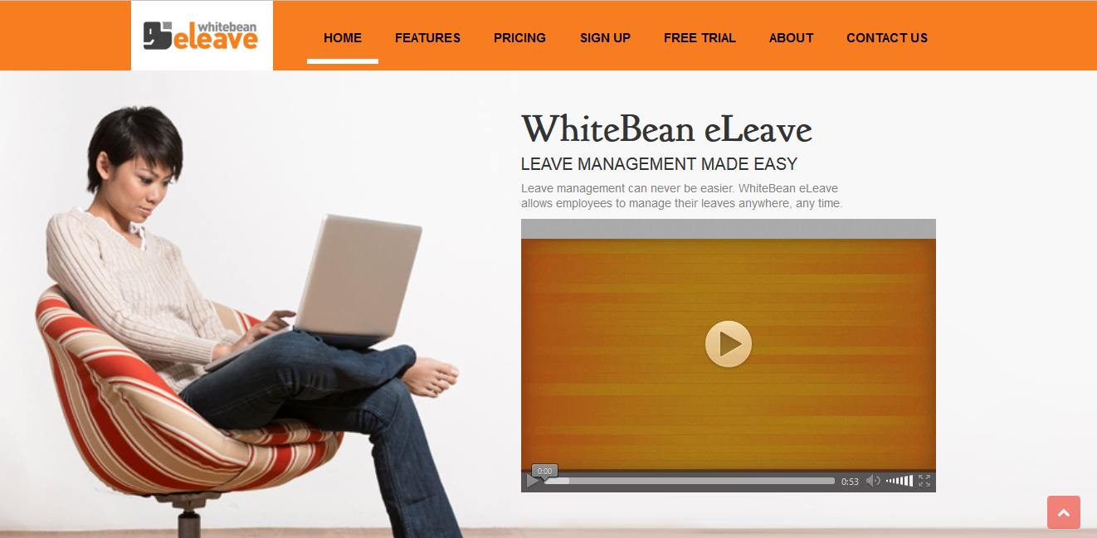

Figure 2 White bean leave system.

**Advantages of the online leave management system**

Users can register from anywhere using the online system to become members.

1. **Security:** The system allows only valid members to access the system. Access to any application resources depends upon user’s designation. Security is based upon the individual username and password. Also security question is involved for efficient recruitment.
2. **Portability:** It can be accessed from anywhere through laptops and desktops with internet connections.
3. **Analysis:** The report can be viewed and analyzed by the supervisors hence know the results and eligibility of the employee for leave in any given time.

2.3 Critique of the existing literature

A detailed analysis of the sites offering online leave management services revealed some gaps on features. Leave management system addresses the research gaps realized as identified for each.

2.4 Research Gaps.

Leave management system addresses the research gaps realized. Analysis of all the two-leave management system.

**Eco-leave management system**

Although this site allows employees to apply for leave, it has the following limitations that has been solved by the online leave management system:

1. Does not provide the employee with an sms notification of approval or denial of leav
2. Does not notify the person incharge of approving or denying leave at the HR department that someone has applied for leave through a text message.
3. Does not provide for multilevels leave approval.

**White bean e-leave system**

Despite free e-leave management system was built on foundations of generic leave allocation functionality and reporting options, it faces the following limitations that has been solved by the use of online leave management system;

1. Does not allow employees to give a brief description for the reason why they are applying for leave
2. Does not notify the person incharge of approving or denying leave at the hr. department that someone has applied for leave through a text message
3. Does not notify the employee to take leave if the employee does not apply for leave at the end of the first six months.
   1. **Summar****y**
   2. The literature review of conceptual framework and other sites already in place in other countries has offered a great framework that gives guidance in the development of this system. The system builds on the current success of previous work and improves on the areas of weaknesses identified, to build a unique and robust system that is not only user friendly but provides solutions to the user requirements.

# 

# CHAPTER THREE

# SYSTEM ANALYSIS AND DESIGN

## **3.1** Introduction

This research is aimed at developing an online system, which manages the leave application process. This system manages the database and maintain a list of all employees belonging to that particular organization. Decisions to approve or deny leave will be done by the HR department in accordance with the policies of that organization.

### **3.2** Development Approach

### **3.2.1 System Design**

System design is the process of producing a design that would define specification of user requirements stated at the system analysis stage. This involves transforming the previously defined specifications into a design that approves the earlier analyzed requirements of the system.

### **3.2.2 Project Design**

Agile methodology is an alternative to waterfall methodology. The system goes through a series of iterations, analyzing, designing, developing and testing each feature in turn within the iterations. In an agile paradigm, every aspect of development — requirements, design, etc. — is continually revisited throughout the lifecycle. It provides opportunities to assess the direction of a project throughout the development lifecycle.(Turk, France, & Rumpe, 2014)

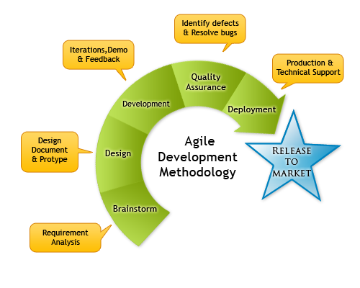

Figure 3 Agile Methodology Diagram

### **3.2.3 Methodology Justification**

Agile is based on the adaptive software development methods. Tasks are divided to small time frames to deliver specific features for a release. As Opposed to Traditional software development modelling tools Agile is a software development model which believes that every project needs to be handled differently and the existing methods need to be tailored to best suit the project requirements. Iterative approach is taken and working software build is delivered after each iteration. Each build is incremental in terms of features; the final build holds all the features required by the customer. Customer interaction is the backbone of Agile methodology, and open communication with minimum documentation are the typical features of Agile development environment. Its main advantages include:

1. Iterative approach is taken and working software build is delivered after each iteration. Each build is incremental in terms of features; the final build holds all the features required by the customer. Customer interaction is the backbone of Agile methodology, and open communication with minimum documentation are the typical features of Agile development environment. Its main advantages include: Is a very realistic approach to software development
2. Functionality can be developed rapidly and demonstrated.
3. Resource requirements are minimum.
4. Delivers early partial working solutions and promotes teamwork and cross training.
5. It is suitable for changing environments and good model for environments that change steadily.
6. Minimal rules, documentation easily employed.
7. Gives flexibility to developers.
8. **Requirements planning phase**

In this phase, the system requirements are collected as much details as possible (Rouse, 2009). There are a lot of methods to gather user requirement such as through interview, active observation, distribute questionnaires and conduct a workshop (Liles, 2012). In order to get user requirement, active and passive observation methods is used for this project. Active observations must be carried out so as to interact with employees who are applying for leave at University of Eldoret, by brief talks with these employees, problems that they are currently facing are easily noted down.

1. **User design phase**

In this phase, the system and software design was prepared from the requirement specifications which were studied in the first phase. System Design helps in specifying hardware and system requirements and also helps in defining overall system architecture. The system design specifications serve as input for the next phase of the model.

1. **Development**

This stage is not distinct. It may involve several iterations during the phase. There is a backlog in which adjustments and new requirements are added during the development phase. First initial functionality is delivered where the system is reviewed by the stakeholders in order to identify any inadequacy and incorporate changing requirements. This makes agile development more flexible compared to waterfall and ensuring higher success rates.

1. **Testing**

In system testing the behavior of whole system/product is tested as defined by the scope of the development project or product. It includes tests based on risks and/or requirement specifications, business process, use cases, or other high-level descriptions of system behavior, interactions with the operating systems, and system resources. System testing also investigated both functional and non-functional requirements of the testing.

1. **Deployment**

After the system pass the testing phase and is operationally satisfactory it was released to the users.

## **3.3** Fact Finding Approach

## **3.3.1 Research Design**

A research design is the plan and structure that outline what should be done from writing hypothesis to final data analysis. The Research design employed is experimental design which is undertaken to better comprehend the nature of this problem. Hakim, C. (2010).

**Experimental Research Design**

Experimental research is one which employs objective, systematic and controlled investigation for the purpose of predicting, controlling and examining probability and causality among selected variable.(Johnson & Turner, 2007) The researcher should have background knowledge of how the system works and understands the points of the current manual system. The researcher has to collect some data from the already existing systems while implementing. In the development phase, after the system is ready it is then tested to see whether its meets the required standards and an improvement made when necessary, then given to a few other users to test if it functions as required. If it is found to meet requirements hence is implemented.

**Advantages of experimental design research**

1. As well as controlling the independent variable the experimenter attempts to eliminate unwanted extraneous variables.
2. Control over extraneous variables is usually greater than in other research methods.
3. Experimental design involves manipulating the independent variable to observe the effect on the dependent variable. This makes it possible to determine a cause and effect relationship.

**Pre-Experimental design for description**

Experimental research can provide data for developing, monitoring and evaluating policies and programs. These designs are concerned with how to answer questions such as: how many? How much? How effective? How adequate? The current manual system revolves around these questions. How many leave application are made on average per day, how much time does it take to complete this process, how efficient and effective is the current system, how adequate and secure is the current system. In the development phase, the system is tested to see whether it meets the required standards and if there are any loop holes or an improvement is to be made, then it will be fixed and given to a few users in the department of Mathematics and Computer Science to test it and if it functions as required, then it is good to be implemented.

### **3.3.2** **Population**

The research has been carried out at University of Eldoret. The targeted population is about 1000 employees, the study comprises of employees from different departments and campuses of the university since all the employees are entitled to leave as provided by the constitution of Kenya under the employment act chapter 226.

### **3.3.3 Sample and Sampling Techniques**

The sampling technique used was stratified sampling where random sampling is done within stratum. Target population at University of Eldoret is estimated to be total of over 1000 employees.

### **3.3.4 Data Collection Tools**

#### **Interviews**

This technique involved a specific set of questions which were directed to the interviewees. Findings during the investigation process were gathered so as to fully identify the problem areas of the existing system. There are some flaws that were identified which the proposed system intends to correct. This stage is an important intermediated stage between investigation and design.

1. **Observation**

An observation was conducted in order to gain first-hand information which regards to the activities, processes and operation of the system on site. The employees were observed on how they apply for leave and the whole process of approval and denial of leave.

#### **Questionnaire**s

The researcher should issue questionnaires to employees of University of Eldoret a combination of both close ended and open questionnaires to be used where the users give either a Yes/No answer to some questions and given the chance to express their opinion in others. The technique is more effective since it enabled most of the users to provide relevant information and this saves a lot of time and resources.

## **3.4 Requirement Analysis**

It is made of two types; namely functional requirements and non-functional requirements. Functional Requirements describes what online leave management system would be doing during its performance to achieve its goal while Non-Functional Requirements describe how online leave management system would perform the functional requirements.

### **3.4.1** Functional Requirements

1. **Registration –** The system is able to accept personal information such as the personal details, the phone number of the users and store it into the database.
2. **Login –** The system is also able to allow the users to do advance searching in order to get close to what they need and not preciously what they need.
3. **Processing-**The system is able to process the leave issuance for either approval or disapproval.
4. **Computations-**The system is able to calculate the remaining leave days to the employee.
5. **Generate report –** The system is able to accept process and output the data in the right format.

### **3.4.2** Non-Functional Requirements

1. **Security –** access control through login security and registration. Due to the administration and usage security to avoid intruders tapping and accessing the information that might be violated to the user’s private rights.
2. **User-friendly –** since the interface of the application contains links, menus, interfaces, which is comfortable enough to enable every targeted user to easily use it.

# 3.5 Logical Design

## **3.5.1 Use Case Diagram**

A Use Case Diagram is a graphical representation that describes how users would interact with the proposed system. It is a graphical representation of the high-level system scope. It includes use cases, which are pieces of the functionality the system, will provide and actors, who are the users of the system.(Bae, Lee, & Chae, 2008)

The Figure 4 below shows a use case diagram that captures the interaction between the system, users and the administrator. Since the system contains private data of the institute of computing and informatics, a secured user login is required. The admin who is in charge of managing the overall data can either login or logout of the system, register employees and head of departments, update their information, manage the daily transactions data of various employees’ activities and generate reports. Employees are able to login, apply for leave, cancel leave applications and logout.

 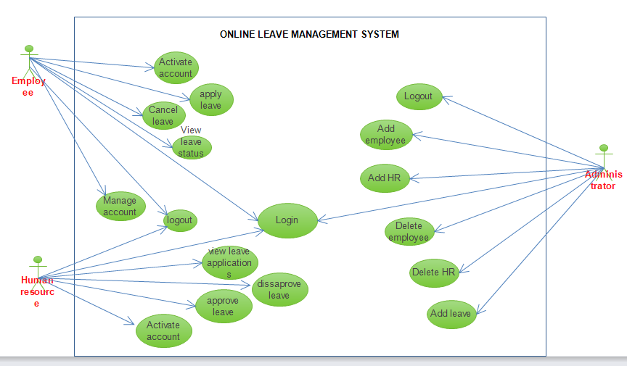

Figure 4 Use case diagram

3.5.2 Data flow diagram

A data flow diagram is a graphical visualization for depicting the flow of data in an information system

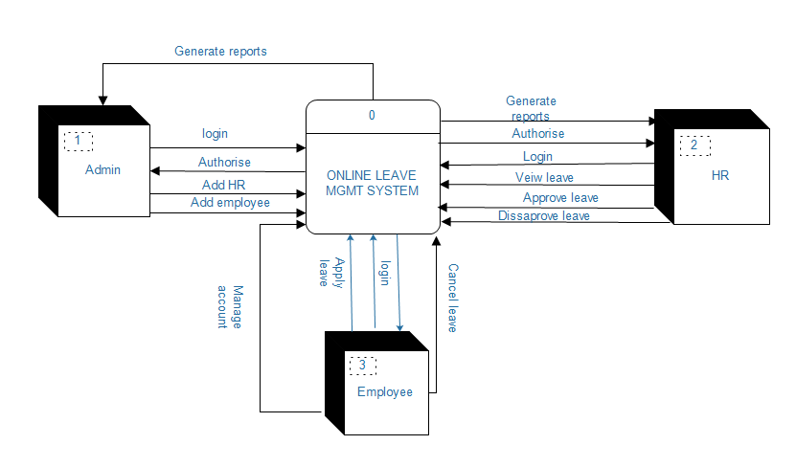

Figure 5 Dataflow diagram

### **3.5.3 Activity Diagram**

The user first login by putting a password and if authenticated he/she proceed to select menu otherwise if password is incorrect; it’s terminated or retry by putting the correct password.

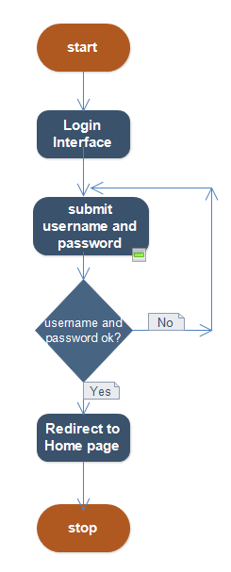

Figure 6 Activity diagram

## **3.5.4 Database design**

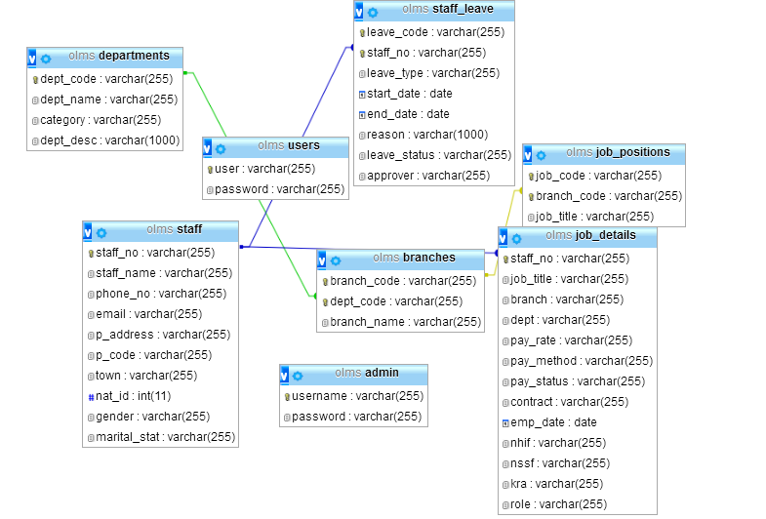

Figure 7 Database schema

## **3.6 Specific Platform**

Due to the sensitivity of the system, there will be need to have a platform that supports and provides efficiency. The researcher used PYTHON in designing the system with MySQL as the back-end database that stores the information. There would be a lot of data that would be requiring a database that supports the facility.

## **3.6.1 Hardware Requirement**

**User**

**Internet enabled devices e.g. a personal computer.**

1. Procesor: Intel Core Duo.
2. At least a 1.3 GHz processor speed.
3. Primary Memory of at least 1GB RAM.

**System Developer**

1. At least a 2 GHz processor speed
2. At least 2 GB RAM Memory

## **3.6.2 Software Requirements**

**Developer**

1. **Programming languages:** PYTHON,HTML.
2. **Styling:**BOOTSTRAP,CSS.
3. **Framework:**DJANGO
4. **Editor :** Visual Studio.
5. **Server:** MySQLite
6. **Platform:** Linux (or) Windows 7/8/10/Vista/ NT/Me/2000/XP/98/95 operating systems.
7. **internet browsers:** e.g. Chrome

**Users**

1. Microsoft Windows e.g. XP, Vista, 7 or 8 or 10 operating system
2. Linux like OS e.g. Ubuntu, MacOS
3. An Internet browser e.g. Chrome.

## **3.7 Summary**

Website system is the current and fast way of accessing and communicating to each other. It is also very reliable and secure way of passing personal information. Everyone is moving from the manual way of doing things to internet where website is one of the ways of access the internet. DJANGO is the current and more reliable language that is used to create more secured systems and is supported in the most of the browsers of the most devices that are used to access the internet. MySQL is an affordable database that can store a lot of information in a more secured and reliable way.

To conclude this chapter the agile methodology has been used since it is a practical approach to design this project and iterative model in transforming the design into the final system. As a result, the design and development of this project adopted approaches in order to deliver the proposed online leave management system.

# CHAPTER FOUR

## **4.1 Introduction**

This chapter describes the basic concepts involved in implimenting system design from the system designer point of view. It deals with turning the proposed system into real running system, screen shots showing the interface of the system are provided to show the various system modules explaining how they work and their relationship to one another. The completed system can be run and viewed on a local Xammp server and browser.

## **4.2 Construction**

This subsection has a clear illustration and functional requirements, explained with regards to different modules in the system. These modules describe different functionalities of the Online Leave Management System, both admin end, supervisors end and employee end are explained using screen shots on how respective personell make use of the system.

Below are different screenshots showing interfaces and other parts of the Online Leave Management System.:

## **4.2.1 Log In screen**

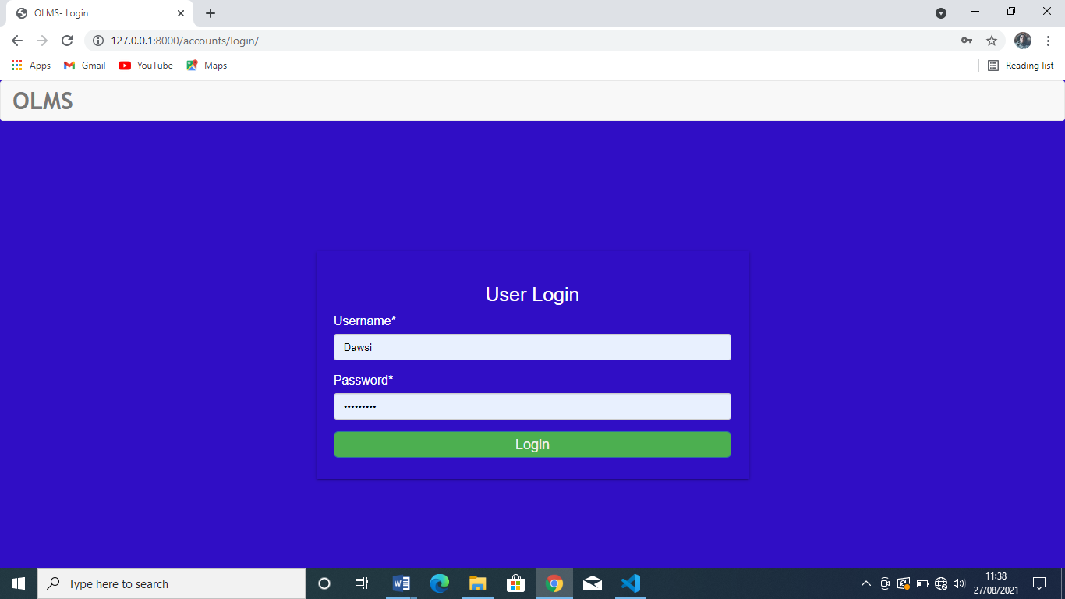

Figure 7 Login page

The figure above shows login screen, Administrator, supervisor and employee enters their username and password. If the login details are correct they will be able to get access to the system.

## **4.2.2 Employee dashboard screen**

After a succesfull login, the employee will be directed to his/her dashboard.

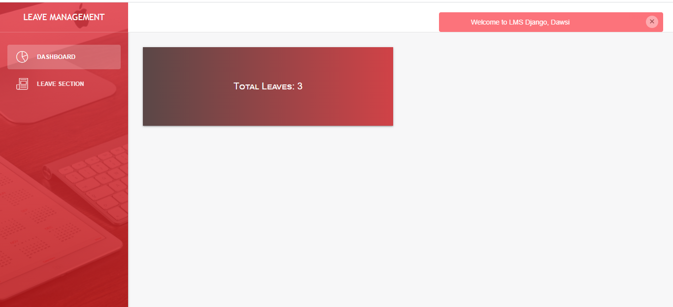

Figure 8 Employee dashboard

**4.2.3 Employee Leave application screen**.

After employee clicks request leave he/she is taken to the screen where he/she can request for leave

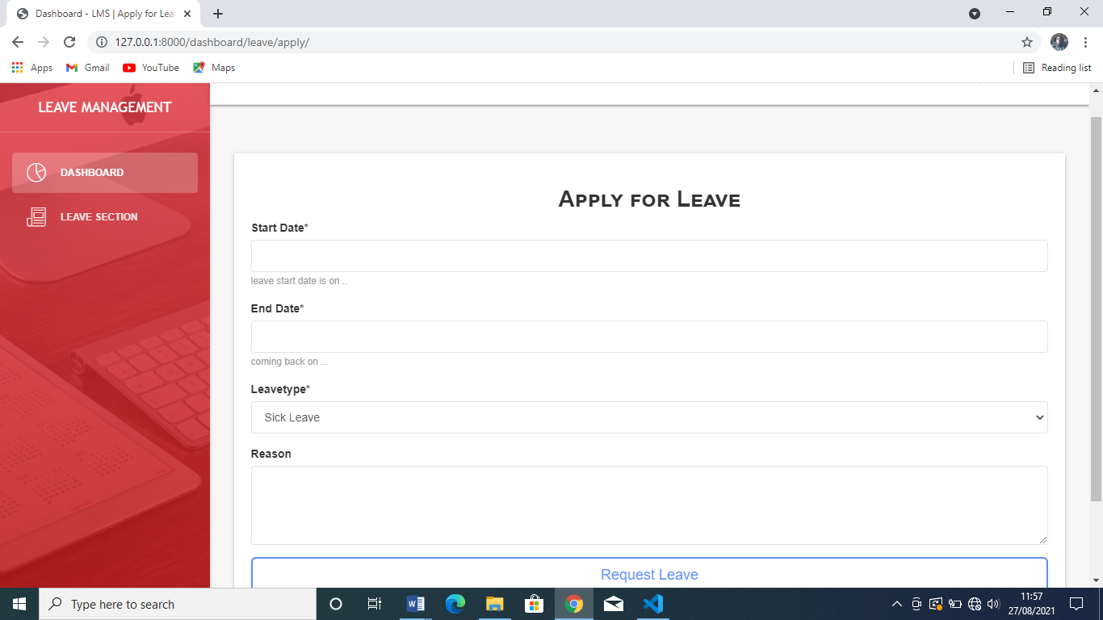

Figure 9 Employee Leave request page

## **4.2.4 Employee profile screen**

This screen shows the employee details.

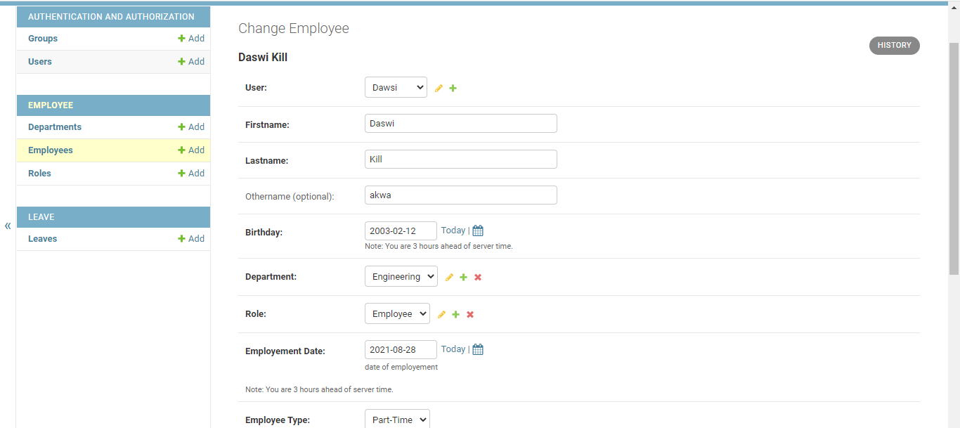

Figure 10 Employee profile page.

## **4.2.5 Supervisor Dashboard Screen**

After a successful log in supervisor I taken to his/her dashboard.

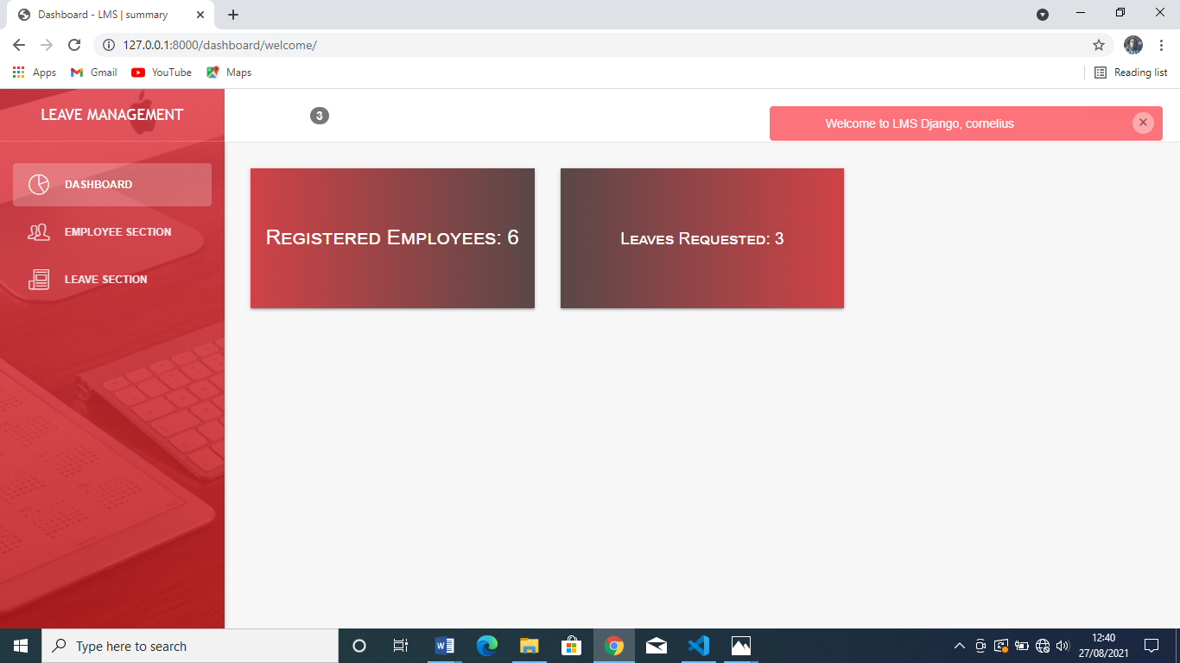

Figure 11 Supervisor Dashboard Page

## **4.2.6 Supervisor approve/reject Screen**

This page shows list of leave requested by employees, supervisor can either approve or reject the requests.

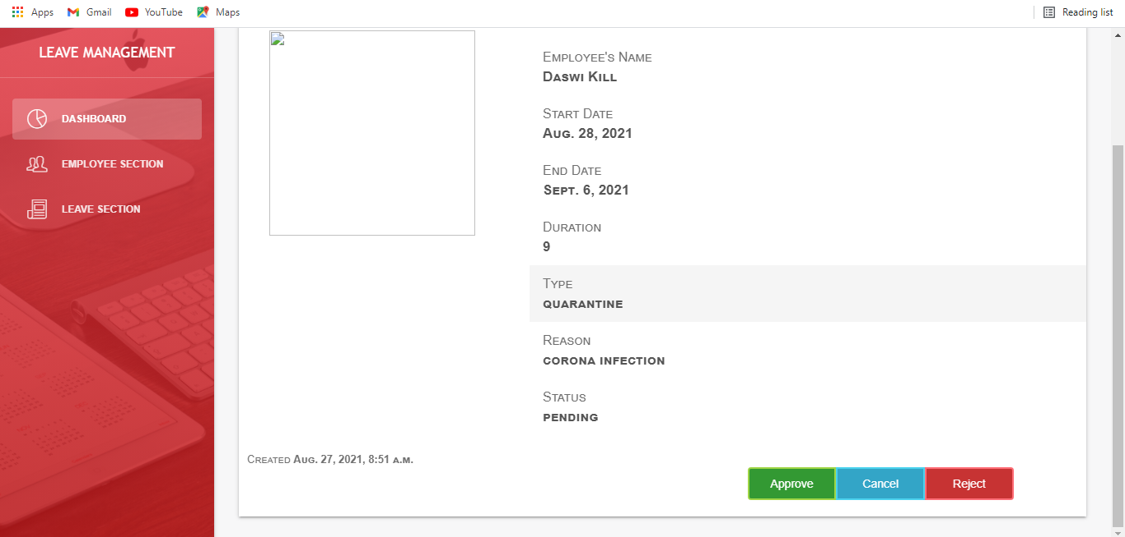

Figure 12 Supervisor Approve/Reject page

## **4.2.8 Admin Dashboard screen**

After a succesfull login, admin is taken to his dashboard.

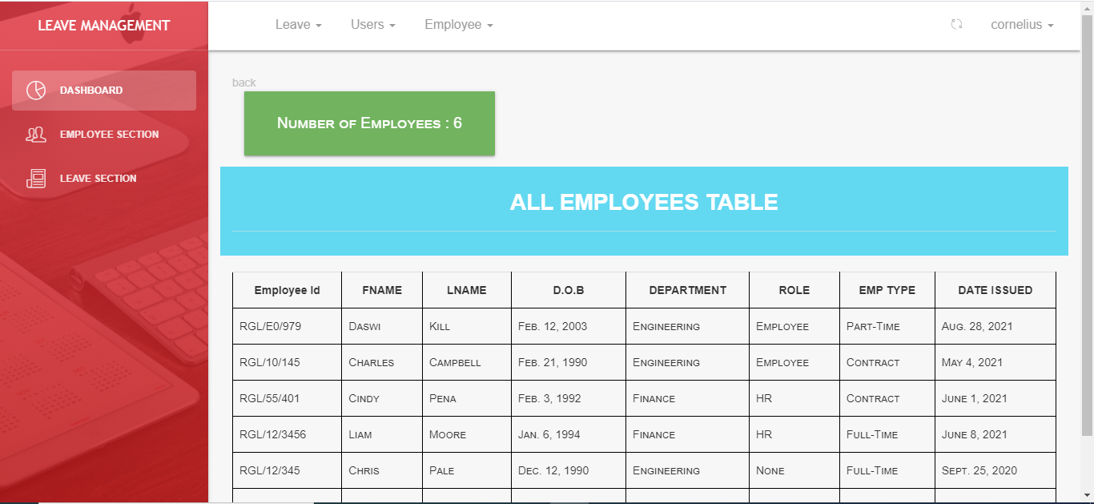

Figure 13 Admin Dashboard Page

## **4.2.9 List of Employee’s Details screen.**

This page shows the list of all the employees added by the admin to the database, While on this page admin can edit or delete employee’s information from the database.



Figure 14 List of employee’s page

## **4.2.10 Adding New Employee Screen**

In this page Admin can add a new employee.

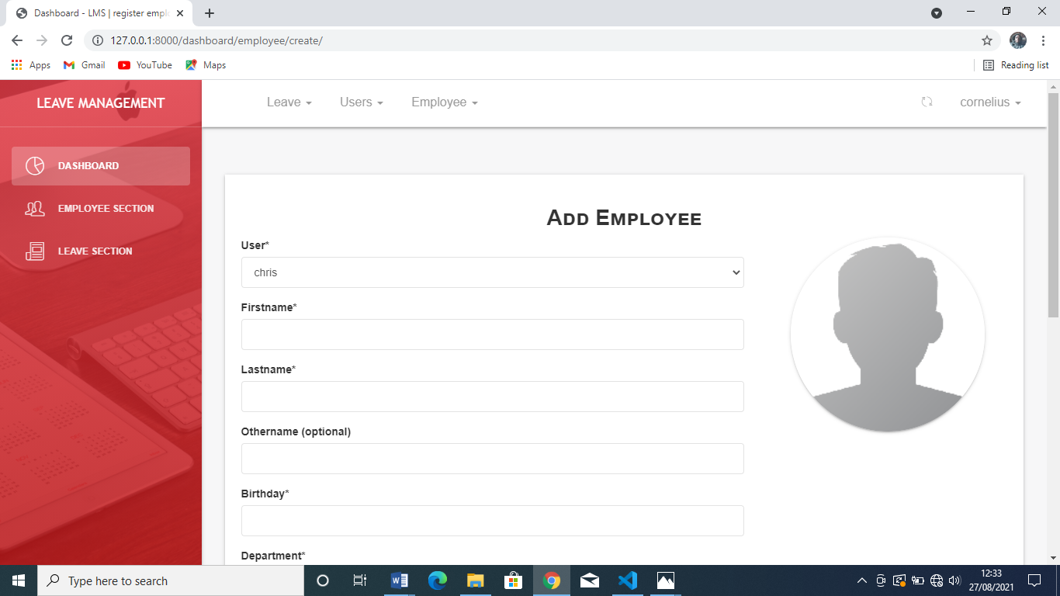

Figure 15 Add new employee screen

## **4.2.11 Adding a New Department screen**

This page allows the administrator to add new department in the ogarnization.

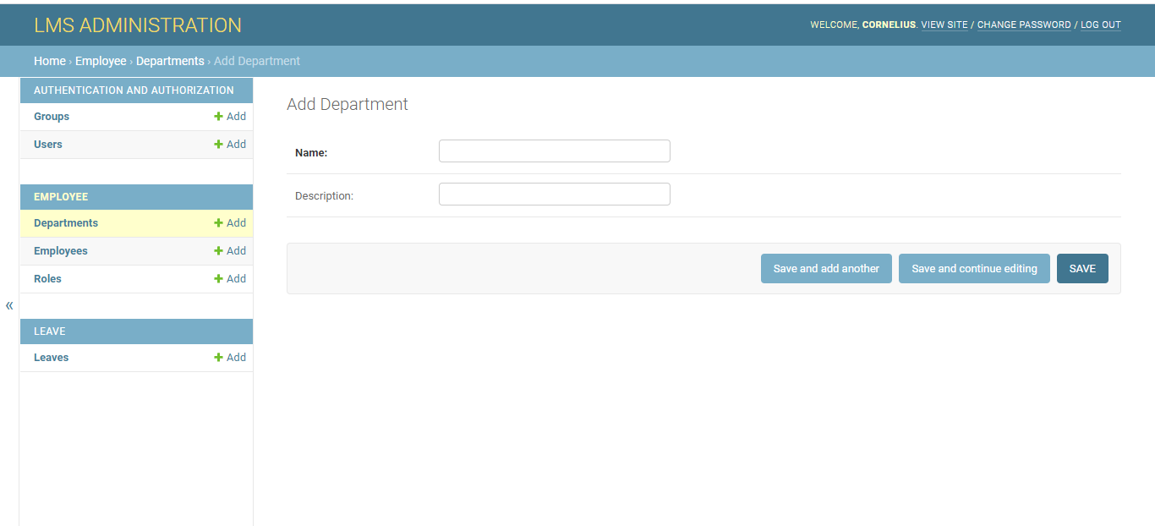

Figure 16 Add New Department Page.

## **4.2.12 List of Leave Request Screen**

This page allows the administrator to view, approve or rejected all the leave requested in the ogarnization.

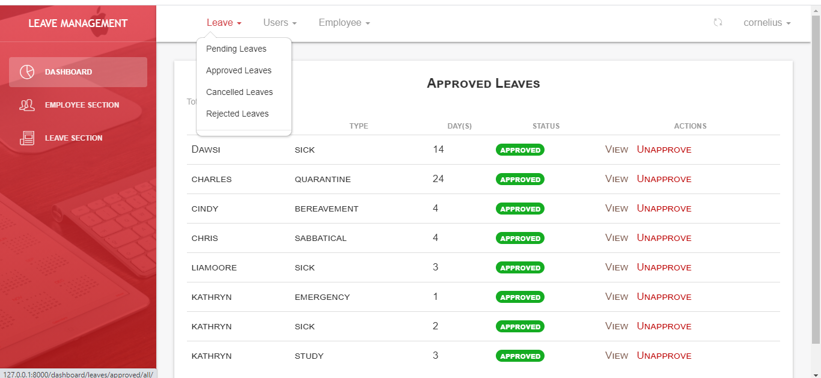

Figure 17 List of leave Requests Page.

## **4.2.13 Report Generation Screen**

This page allows the administrator to generate reports of all leave request, those approved and those rejected.



Fig

## **4.3 Testing**

Testing is a process of checking if a system function as expected, more so if it meets the user requirements. The best way of testing would be to involve users so as to get their feedback. This process is repeated until users are satisfied with the system, however most of the testing is done by developer was on debugging where errors were corrected to satisfy the users. Different types of testing were done as shown below:

## **4.3.1 User Acceptance Test(UAT).**

User acceptance Testing is the last phase of system testing process. During UAT actual system users test the system to make sure it can handle required task in real world situations, according to specifications and meet their expected results. The login module was initially implemented and tested using username and password. Then other modules were as shown in the table below:

## **Table 4.1 User Acceptance Testing**

|  |  |  |  |  |
| --- | --- | --- | --- | --- |
| **Type of Testing** | **Module** | **Objective** | **Expectation** | **Outcome** |
| Unit testing | Add leave types, departments and approve/reject leave requests module. | To check if the administrator can add leave types, departments and approve or reject leave requests. | Authorized employees should be able to login to the system and perform the expected roles. | Successful. |
| Unit testing | Add employee module | To check if the admin can successfully add, view and delete employees from the database. | Admin should be able to add, view and delete employees | Successful. |
| Unit testing | Leave requests module | To check if the employees can apply for leave | Employees should be able to request for leave | Successful |
| Unit testing | List of Leave Requests | To check if the admin can view list of leave requests made and approved or rejected | Admin should be able to get and view list of leave requests made approved or rejected. | Successful. |
|  |  |  |  |  |

## **4.3.2 Beta Test**

It is another stage of user acceptance test phase in the system implementation. It is a form of external testing in which the system is tested in real world scenario by a third party who are not part of development team. For this case study, my friends acted as third party and they tested the system, comparing its functionalities with articulated requirements. The results were as follows in the table below.

## **Table 4.2 User Acceptance Testing**

|  |  |
| --- | --- |
| **Module** | **Outcome** |
| Report Generation | This module meets its requirements. The administrator is able to view all the applications in respective leave types and print the reports. |
| Notification(email) | The employee is able to receive an email notification after his/her leave request has been approved or rejected |

## **4.4 Summary**

The project involved in building an Online Leave Management System which is indeed a very useful system for both the employees, Supervisors and the Human resource managers. It is designed and developed using agile methodology. It involved proper analysis of the user requirements and followed the methodology’s step in creating an online leave management system that meets user needs.

The development of the system is being uses HTML, CSS and jQuery web languages as the development tool for this front-end of the site. On the backend DJANGO tool and MySQL created the database

# CHAPTER FIVE

## **SUMMARY, CONCLUSION AND RECOMMENDATIONS**

### **5.1. Introduction**

This chapter mainly focuses on presenting the summary of the project and future enhancements of the project and shows the achievements of the project. Despite all the challenges, the project was a success in reference to important guidelines from the supervisor and deep research on the area of study as most systems objectives were accomplished.

## **5.2 Conclusion**

The project involved developing an online leave management system which is a very useful system for any organization or institution. It involved proper analysis of the user requirements and followed a methodology’s steps in designing this system that meets the user requirements. Users were involved and consulted during the project implementation and deployment phase, where their recommendation’s and comments matched with the system. The system design method in designing the system was AGILE. The system was done using various development tools, HTML, CSS and JavaScript web languages with PYTHON designer serving as the development tool for most part of the system. Xammp server provider the webserver (apache) and MySQLite3 created he database.

Various testing techniques were employed to identify any errors and ensure that the system was ready for use, since the current manual system is not efficient in leave application processes. It is the best decision for the University of Eldoret to start using the online leave management system. This system enhances efficiency, reliability and data security.

## **5.3 System constrains**

The system lacks direct communication between the employee and the administrator, direct communication could have helped the employee notify the administrator once he/she has returned from leave, also the system does not limit the number of leave days that each employee can take as required by the constitution.

## **5.4 Future Enhancements and Recommendations**

Online leave management system was developed to address most of the shortcomings of the initial or current systems. It address most of these challenges, if its deployment would therefore, improve most operations efficiency and convenience.

In the future, a mobile application of this system would work well to improve convenience.

Also in future a module can be added so that an employee will be able to notify the administrator after returning from leave

Finally in future a module of limiting the number of days that each employee can take can be added to make the system more efficient and more reliable.

## **REFERENCES**

Lohr, L., Javeri, M., Mahoney, C., Gall, J., Li, K., & Strongin, D. (2013).

Qualitative Inquiry and Research Design: Choosing Among Five Approaches. (n.d.). RetrievedNovember 9, 2016, from http://hpp.sagepub.com/content/early/2015/04/02/1524839915580941.abstract

Thite, M., Kavanagh, M. J., & JOHNSON, R. D. (2012). Evolution of human resource management and human resource information systems.

Turk, D., France, R., & Rumpe, B. (2014). Limitations of Agile Software Processes.

Whitehouse, G. M., Baird, M., & Hosking, A. (2007). Maternity leave in Australia.

Johnson, R. B., Onwuegbuzie, A. J., & Turner, L. A. (2007). Toward a Definition of Mixed Methods Research. *Journal of Mixed Methods Research*, *1*(2), 112–133. https://doi.org/10.1177/1558689806298224

WhiteBean eLeave Malaysia • Leave Management Malaysia. (n.d.). Retrieved November 8, 2016, from http://www.eleave.asia/

Skinner, N. J., & Chapman, J. (2013). *Work-life balance and family friendly policies* (Doctoral dissertation, ANZSOG-The Australia and New Zealand School o).

Normalini, Md. Kassim, T. Ramayah, & Sherah Kurnia. (2012). Antecedents and outcomes of human resource information system (HRIS) use. *International Journal of Productivity and Performance Management*, *61*(6), 603–623. https://doi.org/10.1108/17410401211249184

Turk, D., France, R., & Rumpe, B. (2014). Limitations of Agile Software Processes. *arXiv:1409.6600 [Cs]*. Retrieved from http://arxiv.org/abs/1409.6600

# Appendices

### **Appendix 1: Project Budget**

|  |  |  |  |  |
| --- | --- | --- | --- | --- |
| NO | ITEM | QUANTITY | UNIT PRICE | AMOUNT |
| 1 | Laptop | 1 | 41,000 | 41,000 |
|  | Flash disk | 1 8GB | 1,000 | 1,000 |
| 3 | Transport | ----- | 1500 | 1500 |
| 4 | Communication (airtime) | ----- | 300 | 500 |
| 5 | Printing (Documentation) |  | 1000 | 1000 |
|  | Miscellaneous |  | 1000 | 1000 |

### **Appendix 2: Work Plan and Project Timeline**

|  |  |  |  |  |  |
| --- | --- | --- | --- | --- | --- |
| **Activity** | **Feb-Mar** | **April-June** | **June-July** | **July-Aug** | **August** |
| **Proposal** |  |  |  |  |  |
| **User & System Requirement** |  |  |  |  |  |
| **Physical & Logical Design** |  |  |  |  |  |
| **Coding** |  |  |  |  |  |
| **System Testing** |  |  |  |  |  |
| **Presentation & Reporting** |  |  |  |  |  |
| **Documentation** |  |  |  |  |  |